

Business Plan

Contact: | David Cornelson
1144 East State St. Suite A
Geneva, IL 60134
(630) 803-4302
david@textfyre.com

Table of Contents

1.0 Executive Summary 2
2.0 Company Overview 4
2.1 Mission Statement 4
2.2 Textfyre’s Products 4
2.3 Development to Date 5
3.0 Industry Analysis & Trends 6
3.1 History and Background 6
3.2 Industry Size and Composition 6
3.3 Adventure Games 6
4.0 Market Analysis 7
4.1 Primary vs. Middle School 7
4.2 Gender Differences 7
4.3 Market Size 7
4.4 Target Market 8
5.0 Competitive Analysis 9
5.1 Direct Competition 9
5.2 Indirect Competition 9
5.3 Textfyre’s Competitive Strengths 9
6.0 Marketing & Sales Strategy 11
6.1 Advertising & Promotional Strategy 11
6.2 Pricing 13
6.3 Sales Strategy 13
6.4 Distribution 13
7.0 Operations Plan 14
7.1 Location 14
7.2 Contractor Compensation 14
7.3 Suppliers 14
7.4 Customer Returns 14
7.5 R&D Schedule 14
8.0 Management & Organization 15
8.1 Key Personnel 15
8.2 Ownership and Advisors 15
9.0 Future Development 16
10.0 Financials 17
10.1 Sources & Uses of Funds 17
10.2 Financial Analysis 17

1.0 Executive Summary

Textfyre, Inc. was formed as a subchapter S corporation in 2007 by founder David Cornelson. The business is located in Geneva, IL and produces interactive fiction software for the youth market. Interactive fiction combines learning with fun for children, while simultaneously developing reading and cognitive thinking skills.

Interactive fiction has been around since the late 1970s, but lost ground to video games in the mid to late 1980s. Despite the lack of commercial success in recent years, interactive fiction has been sustained by enthusiasts who create and freely distribute their products. With the rise of the educational toy market and the strong youth demographic, Mr. Cornelson saw an opportunity to bring interactive fiction to the market.

Currently, only one competitor commercially sells interactive fiction, Malinche Entertainment. This company has five titles available and targets the adult market with genres including murder mystery, action adventure, and horror. Indirect competitors include video games, books, and other learning software. Textfyre intends to differentiate itself by targeting children between the ages of eight and fourteen, co-packaging their products with complementary products (comic books, game cards, etc), and distributing through the web and retail outlets.

Textfyre has chosen two targets to market its products – parents and children 8-14 years old. Parents will appreciate the educational aspect as well as its non-violent content. Children ages eight to fourteen are in a developmental stage where reading and computers are appealing and necessary for school. Textfyre believes that its entertaining, non-traditional format will be welcomed by both parents and children alike.

To reach this market, Textfyre has developed a roll-out strategy for measured growth. It will first focus on online distribution from its own website before moving to other online retailers as the games gain traction. The company will also seek out retailers, like Barnes & Noble and Borders, to sell its software games in their “young reader” sections. Building awareness will be employed through a mix of online advertising and tradeshow attendance.

Textfyre is managed by its CEO and founder, David Cornelson. Mr. Cornelson oversees all aspects of the company, especially its game development contractors. Textfyre has assembled a team of writers, designers, and programmers to assist in game development. The company also has a well-rounded advisory board to assist Mr. Cornelson in strategy development and execution.

To date, Textfyre is near completion of its first interactive fiction product. The product is in the implementation phase and will be starting testing soon. A second product has also begun the creation process and will be ready for market by the end of 2007. The company plans an aggressive product launch schedule with 12 additional titles created in 2008 and 24 new titles in 2009.

This launch strategy promises to be fruitful for the company, with revenues growing from $150,000 in 2008 to $676,000 in 2010. Profit margins remain strong due to the number of titles available and operational efficiencies.

2.0 Company Overview

Textfyre, Inc., was founded in 2006 by David Cornelson and is based in Geneva, IL. Textfyre produces interactive fiction that simultaneously educates and entertains children. Interactive fiction brings books to life with the “reader” or player becoming part of the story and choosing the actions of the main character. This allows for children to develop cognitive thinking skills and increases reading proficiency and comprehension.

The idea for Textfyre was initially born as a hobby of the founder. The interactive fiction industry was popularized in the 1980s, however early companies didn’t adapt to the video game market or were absorbed by video game companies, which didn’t see a value in continuing to publish high quality interactive fiction. The medium was quietly maintained by hobbyists who developed their own games and shared them freely with other enthusiasts over Usenet and later the Internet. As the educational toy market and youth demographic continues to grow, Mr. Cornelson sees an opportunity to bring interactive fiction back to market.

2.1 Mission Statement
Textfyre will be a parent’s ally in the effort to educate their children. Textfyre’s goal is to have the highest quality yet entertaining interactive fiction on the market. The company aims to combine talent, creativity, and business acumen to sustain success and growth.

2.2 Textfyre’s Products
Textfyre will be a publisher of interactive fiction, combining computer games and storybooks. Interactive games incorporate both text and graphics. The player can see graphics and read along with the story. They are also able to interact with the characters and influence their environment by typing word commands. The character follows these directions and the story changes in response to the player’s commands. This interaction allows the game to be played multiple times without duplication.

Key features of the storybooks include:
- The virtual storybook will consist of basic commands such as: north, south, open door, up and down.
- As the player continues through the story, more complex sentences create more interactivity for the player, such as: climb the north wall or open the gold chest with the silver key.
- Other characters in the story can provide help when asked.
- Players do not have to go page by page in a linear fashion; they have the freedom to move to and from different parts of the story.

Each product will include a full color comic book and/or a card game. Additional offerings may also be packaged with the software as determined by the storyline.

Textfyre’s first product offering involves a young female character, Jacqueline “Jack” Toresal. Jack is a fourteen year old orphan with an education paid for by an anonymous sponsor living in a fantasy kingdom world. She decides to seek out her benefactor in disguise as a boy and eventually finds she is the heir to the local lands and may be eligible for the Kingdom throne. This storyline offers adventure in a fantasy world by a character close in age to the target market.
An image of the main character, Jack, is in Appendix A.

2.3 Development to Date
Textfyre is currently in the start-up phase of development. To date, the following tasks have been completed or are in development:
- $9,500, three year loan has been secured
- All necessary paperwork has been filed with the city and state
- Key illustrators and programmers have been contracted
- First interactive fiction product will be completed by Fall 2007
- Second product has begun the creative design process and will be completed by December 2007
- Character and title trademarks will be sought by Fall 2007
- Future development includes:
    - 12 products will be created and distributed in 2008
    - 24 products will be created and distributed in 2009

3.0 Industry Analysis & Trends

3.1 History and Background
Interactive fiction was originally developed by Will Crowther in 1975 with the simple game Adventure. Don Woods of the Stanford Artificial Intelligence Laboratory re-envisioned Adventure with more advanced technology and an expanded storyline in 1977. Both versions of the game ignited interest in interactive fiction and led to its widespread success in the 1980s.

Infocom was the largest company to produce interactive fiction and released a number of very popular titles before being acquired in 1986 by Activision, a well known computer and video game company. The rise of video games in the late 1980s put many of the interactive fiction producers out of business as players responded to the enhanced graphics, sounds, and technological capabilities.

Interactive fiction made a brief resurgence in the 1990s by incorporating many of the characteristics of video games, but was never able to gain significant traction or market share. All notable entrants were purchased by video game companies and incorporated into their gaming portfolio.

3.2 Industry Size and Composition
The interactive fiction industry has become a small niche market with very few producers and competitors. As mentioned earlier, most of the industry is self-produced and informally distributed for free by interactive fiction enthusiasts. Industry insiders estimate that up to thousands of new games have been developed since the birth of interactive fiction. Despite the lack of commercial support, the availability of high quality tools and competitions allow enthusiasts to develop new, high quality games.

3.3 Adventure Games
Interactive fiction is often considered to be an adventure game. Adventure games are a type of computer entertainment program that are interactive and based on a storyline. These games follow the same story conventions as literature or film. Adventure games include genres such as: fantasy, science fiction, mystery, horror, and comedy.

4.0 Market Analysis

4.1 Primary vs. Middle School
Textfyre will target children between the ages of eight and fourteen. These children are in primary or middle school. Primary school students (K-4th grade) are at a developmental age where they are naturally inquisitive and are interested in reading as a hobby. They are also old enough to have had exposure to the computer and its basic functions. Middle school children (5th-8th grade) read primarily to meet school demands, but have increasing interest in video games and technology. Textfyre appeals to the desires of both primary and middle school children by providing an offering that meets both their needs.

4.2 Gender Differences
Both boys and girls will find interest in Textfyre’s products as they combine reading with text adventure games. The International Reading Association found:
- Girls read more than boys; 39% of boys found reading to be boring
- Boys tend to resist reading stories about girls
- Girls do not tend to resist reading stories about boys
- Boys read less fiction than girls; preferring graphic novels and comic books
- Boys tend to be more interested in video/computer games

4.3 Market Size
Research is not available among the current target market within the interactive fiction industry. The current market is very small and dominated by adults who create the games themselves. Therefore, market size was estimated by using data from The Lifestyle Market Analyst combined with the U.S. Census.

Families with Children under the Age of Thirteen that Own a Computer:

PC Owners | 4,687,000
Macintosh Owners | 626,000
Total | 5,313,000

Population estimate of the target market:

Ages 5-9 | 19,539,000
Ages 10-14 | 20,858,000
Total | 40,397,000
Of the total:
49% Girls | 51% Boys

The data listed above suggests that there are a significant number of potential consumers.
Products produced by Textfyre will be easily sold to parents because of their educational and nonviolent appeal. These games will be educational, not because consumers will have to solve math questions to move forward, but because the games will teach young consumers basic computer and reading skills.

4.4 Target Market
Textfyre will have two distinct yet complementary target markets – children and parents.

The company will target children between the ages of 8 and 14 years old who enjoy reading and are computer literate. Textfyre’s computerized text adventures will likely have more female than male buyers. Research has concluded that girls will be more open to interactive fiction and adventure storylines and it combines their interest in reading and computers.

Parents will also be a secondary target. Parents want their children to develop the necessary skills for advancement, many of which coincide with the games’ features. This includes reading comprehension and skill advancement, problem solving, critical thinking, and creativity. These games will also be non-violent which is rare in the computer/video/book market. Parents, more than ever, are looking for games for their kids that are not violent. Research has shown that video game violence has been shown to increase the chance of violent behavior in kids.
The combination of a technologically advanced storybook with excellent, non-violent computer graphics will appeal to parents and young consumers. This appeal will make household buying decisions easier as there will no longer be arguments about which games the child wants versus what the parent wants.

5.0 Competitive Analysis

5.1 Direct Competition
There is currently only one direct competitor in the commercial interactive fiction market. Malinche Entertainment was founded in 2002 and has sold over 100,000 copies of its first three titles. Currently, the company offers four titles for consumers with its fifth released earlier this year. Malinche carries titles in genres such as murder mysteries, action adventure, and horror. All titles currently appear to be aimed at an adult target market

All titles are offered in disc, PDA, cell phone, and iPod formats which range in price from $9.95 to $34.95. An individual can download a smaller, more condensed version of the storyline to their iPod for $9.95. For $24.95, the consumer can receive a full version of the title over E-Mail download, which also comes with the ability to be placed on specific cell phones and PDAs. Finally, the $34.95 option includes the delivery of a disc copy of the game along with related paraphernalia.

5.2 Indirect Competition
Further research of the market yielded three industries that would be indirect competitors. Video games, traditional books and interactive learning software all show significant competition for the company.

Video games have become extremely popular among a very wide age group. Since their introduction video games have continued to evolve at a fairly quick rate; leading consoles such as XBOX and Playstation are continually pushing the limits on their equipment to give the user interactive experiences that surpass those of its competitors.

Traditional books have withstood the test of time and have been a source of entertainment for ages. In this area, Textfyre offers consumers a product that is not mainstream. Many children have never heard of interactive fiction which gives the company an opportunity to renew interest in reading and help the product grow.

Learning software is a very common purchase for parents for their children. Because interactive fiction involves reading, parents may recognize its ability to improve reading skills in their young children. The popularity of all these products among consumers is already very high but Textfyre has advantages in the marketplace that give it a jump-start in front of its direct competition.

5.3 Textfyre’s Competitive Strengths
The strengths listed below may allow Textfyre to successfully compete in the market place:
- Significantly younger target market than its direct competitor. By reaching this market the company will be able to establish a new consumer base which it can expand off of.
- First interactive fiction novels to be accompanied by graphic art throughout the story line.
- Retail distribution strategy. Availability at store locations can help raise awareness to those consumers who are not yet familiar with interactive fiction as well as give those who do not like to purchase over the Internet the opportunity to buy.

6.0 Marketing & Sales Strategy

Textfyre will focus its marketing efforts on its unique combination of education and entertainment in a convenient location at an affordable price within its niche segment. Marketing and sales will be targeted to both the children and parent markets through a variety of marketing tactics.

6.1 Advertising & Promotional Strategy
The marketing strategy will be implemented via a number of methods and channels based on market and demographic research. The advertising strategy will focus on three key areas:
- Online advertising
- Cooperative advertising campaigns with both online and conventional retailers
- Tradeshows and school events

Online Advertising
Internet advertising has multiple advantages that are attractive to Textfyre. It is relatively low cost yet has immediate placement, and therefore is very suitable for Textfyre’s limited advertising budget. In addition to the low cost, internet advertising provides vast marketing exposure. Millions of people use the internet to search for products, thus allowing Textfyre to penetrate other markets at a fraction of the cost of traditional advertising methods. Advertising on the internet does not only reach the ideal target market, it reaches and informs other potential consumer markets as well. Textfyre will be able to reach millions of potential customers and position the company for success, without the need for a costly infrastructure and overwhelming marketing costs.

All online ads will refer the consumer to Textfyre’s website and allow the consumer to learn the benefits and features of the products. Consumers will also be able to post user reviews and ratings of the software. This will help Textfyre effectively heighten brand awareness for new products while strengthening customer relations.

Advertising online also allows Textfyre to measure its marketing success as well as capture valuable data about its current and potential customers. Textfyre can use internet tools that provide real time statistics, on unique visitors, repeat visitors, and click through rates on advertisements. This provides them with important details about their web visitors and advertisements, allowing them to evaluate the effectiveness of each marketing campaign. This allows them to determine what programs work for their particular market and make any changes in their marketing strategies.

Cooperative Advertising
In addition to Textfyre’s online advertising, Textfyre will engage in cooperative advertising with retailers. This will include marketing campaigns with online retailers, such as Amazon.com, and conventional retail stores, such as Barnes & Noble and Borders.

Amazon.com
Amazon provides the business, marketing and vendor support necessary to maximize sales. Amazon allows vendors to control the content on their product detail page, but also offer professional assistance to help the vendor best market and emphasize their product features. This will be quite beneficial to Textfyre. Considering Amazon’s marketing suggestions, Textfyre would include in depth descriptions and product reviews. Textfyre would also upload screen shot animations and short video clips from the software. This would give the consumer insight into what the game looks like and how it actually functions. Amazon also provides vendors with a variety of marketing features to help increase product placement and exposure. Amazon’s auto-merchandising program will proactively display and market Textfyre’s products to potential customers.

This personalization technology helps customers navigate the site to not only find the products they are looking for, but also to discover products they did not know existed. This is extremely beneficial as consumers who may not know about Textfyre’s software will be exposed to it through Amazon’s “personalization” marketing programs. More specifically, Amazon’s personalization technology markets products through their product pairings, such as the “Customers who bought this…also bought this” feature. This suggests similar products to that which the consumer is viewing.

Textfyre would also utilize Amazon’s gold box marketing program and the “new product emails.” The gold box uses Amazon’s personalization technology to suggest, to each Amazon.com customer, ten new products everyday. The new product emails are intended to inform and market new products to Amazon members. These programs level the playing field for Textfyre, because Amazon provides Textfyre with the tools and framework to ensure its software appears frequently and prominently on Amazon.com.

Retail Stores
Textfyre will also participate in cooperative advertising with retail stores. This will include setting up special product displays showcasing Textfyre’s software. These displays will draw attention to Textfyre’s products, increase consumer awareness, and also emphasize the products’ features. Additionally, retailers will include information about Textfyre’s products in their customer mailings. These mailings will include details about and reviews of Textfyre’s software. While these mailings will not reach quite as many potential customers as internet advertising, it will market to consumers that may not be exposed to internet marketing. It also simply provides another low cost medium by which Textfyre can increase product awareness.

Trade Shows
Textfyre will use brochures and printed materials to distribute to potential customers at tradeshows, schools, and libraries. At tradeshows, Textfyre will use its marketing materials to inform others in the book and gaming industries about its software. This will alert others of Textfyre’s presence and help develop valuable contacts in the industry. At schools and libraries, Textfyre will use the marketing materials to reach the target market and make them aware of Textfyre’s new software. Because the market is relatively unfamiliar with Textfyre, this will provide the company with an opportunity to build awareness of interactive fiction.

6.2 Pricing
The pricing strategy for Textfyre’s product was based in part on the company’s financials and in part on the company’s indirect competition. Since Textfyre’s game is, in a broader category, computer software, its closest competition is believed to be other computer software games. Most of these games are selling in the $20 range, except when downloaded directly from the internet where they are frequently offered at a small discount.

The company decided that titles will be priced in-store at $19.95 and $14.95 over the internet. Downloadable versions will be almost completely profit. This price is on par with competitive products, such as Cradle of Rome, and Dream Day Wedding which are both priced at $19.99.

6.3 Sales Strategy
Textfyre’s founder, David Cornelson, will conduct all direct sales activities. Mr. Cornelson will be charged with attending industry events, growing awareness of the interactive fiction market, and acquiring retail distributors.

6.4 Distribution
Textfyre will distribute through both online outlets and conventional retail stores. Textfyre will initially sell their games through the company’s online store. After six months, Textfyre will expand its product distribution by discounting the games for purchase through popular internet outlet stores such as Amazon.com. As the company’s sales grow online, Textfyre intends to distribute and sell the software at retail bookstores, such as Barnes & Noble and Borders. The software will be displayed in the “Young Reader” section of the bookstore, where it will best reach its target market.

7.0 Operations Plan

7.1 Location
Textfyre will operate as a virtual business. With an all contractor staff, the company has determined that no physical location is necessary in the short term. The company is headquartered out of the home of the founder, David Cornelson, in Geneva, IL.

As the company grows, a physical office may be sought as employees are hired.

7.2 Contractor Compensation
Textfyre will not have any employees in the short term, relying on freelance professionals to work on a contract basis. The company has negotiated standard industry payment policies for each contractor, including:
- Writers are paid per word and receive no royalties
- Programmers are paid a flat fee and receive no royalties
- Game designers are paid standard book author percentages – 10% for the first 5,000 copies sold, 12.5% for the second 5,000 sold, and 15% for all copies sold over 10,000

7.3 Suppliers
Textfyre is in the process of securing a fulfillment company to provide printing, packaging, inventory, and shipping services. The company anticipates placing orders in increments of 2,000 on an as-needed basis to keep inventory low and costs down. Textfyre has been researching potential vendors and plans to have a contract in place by December, 2007 when the first game will be ready for distribution.

7.4 Customer Returns
All packaged games will eligible for a full refund within seven days of purchase or anytime if the product has retained its original packaging. Downloaded games will be reviewed by management on a case by case basis, based on discussions with the customer.

7.5 R&D Schedule
Currently, it takes 4-6 months to produce each game with the current staff of writers, designers, and programmers. It is estimated that this timeline will be reduced to three months as experience improves and efficiencies arise. To reduce development time, Textfyre plans to use the same staff of contractors as future games are developed.

8.0 Management & Organization

8.1 Key Personnel
David Cornelson, CEO, is an IT consultant of twenty-two years having worked on projects at many Fortune 500 corporations in the healthcare, insurance, financial, and manufacturing industries. Mr. Cornelson will oversee the day-to-day operations of the company and is responsible for developing its strategy and direction. He will ensure all aspects of Textfyre’s operations are efficient, meeting productivity goals, and the proper personnel are in place. He will also oversee all sales efforts, financials, and quality controls for new product development.

The following contractors have made significant contributions to the development of the first and second product offerings.
- Erika Richardson, Graphic design and illustration
- Michael Gentry, Interactive fiction writer
- Jeff Panici, Systems programmer
- Graeme Jefferis, Inform 7 programmer
- Ian Finley, Interactive fiction writer and designer
- Jon Ingold, Interactive fiction writer and designer
- Jason Terhorst, Interactive user interface designer

As the company grows, Textfyre anticipates hiring or contracting a financial manager and a sales and marketing specialist.

8.2 Ownership and Advisors
David Cornelson has full ownership of Textfyre, Inc., an Illinois subchapter “S” corporation. The Company’s advisors include:
- Jack Cummins, Attorney
- Dr. William Kolomyjec, Cognitive learning
- Kapil Sood, Business advisor
- Jeff Tagge, Publishing
- Dennis Jerz, New media
- Nick Montfort, Interactive fiction

9.0 Future Development

Textfyre will continue to grow by offering more products, multi-user formats, handheld games, and distribution alternatives. This strategy allows the company to grow at a measured pace and with further market analysis. Some of the developments are:
- Voice-controlled games
- Multi-user games
- Games available in other languages
- Downloads appropriate for cellular phones and iPods
- Handheld devices
Textfyre also holds all of the rights to merchandising as well as book publication and movie/TV development.

10.0 Financials

10.1 Sources & Uses of Funds
Textfyre has secured a $9,500 loan payable over three years. This sum is in addition to the owner equity invested by David Cornelson to cover all developmental costs to date as well as launch expenses.

The company does not anticipate any additional rounds of financing as it intends to self-finance all future growth.

10.2 Financial Analysis

Textfyre believes that it will be able launch 14 interactive fiction games by the end of 2008, and an additional 24 games each year thereafter. With this product launch schedule, the company will be able to grow quickly by reinvesting its profits while reducing costs through efficiencies.

The company anticipates generating $150,000 in revenue by the end of 2008, with a 26% profit margin. This number grows steadily each year at 85% in the second year and 142% in the third full year of operations as more interactive fiction games are introduced and the awareness solidifies.
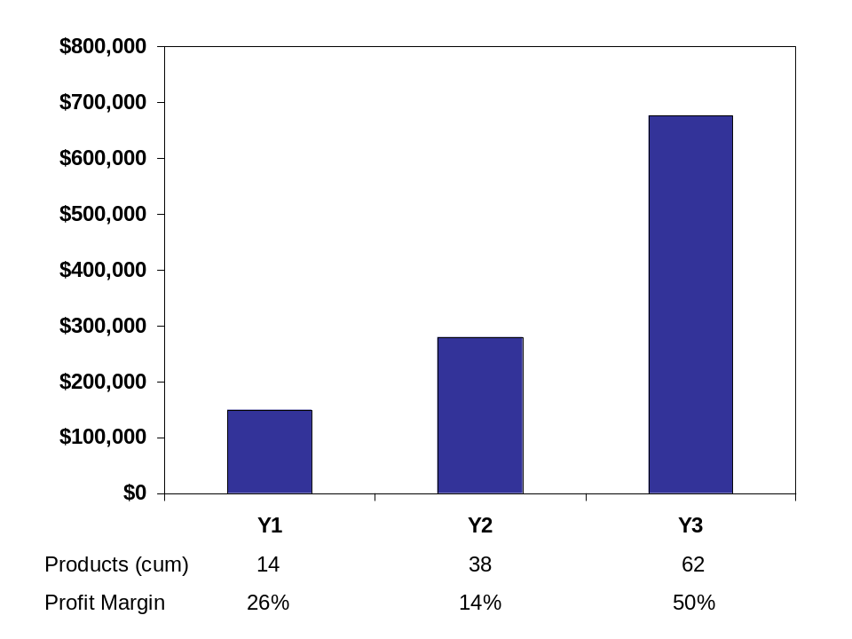

With little debt, the company is profitable from the beginning and reaps cost saving almost immediately through the retention of key contract employees who are integral in the development process. Their experience aids in keeping costs low relative to growth. Operational expenses nearly double in year 2 but cost increases slow to 39% in year 3 despite an aggressive product launch strategy.
Appendix A

Jacqueline “Jack” Toresal, main character of the first product offering by Textfyre:

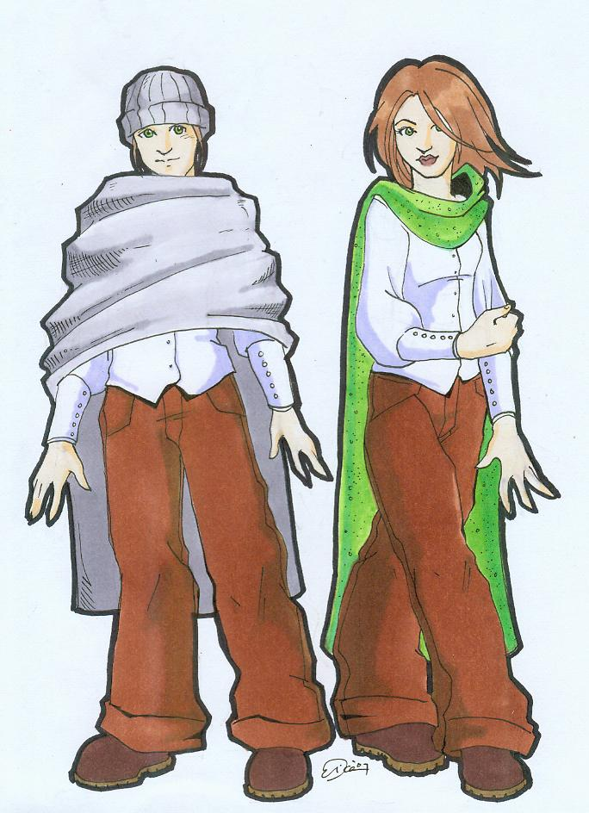

Appendix B
2008 Income Statement

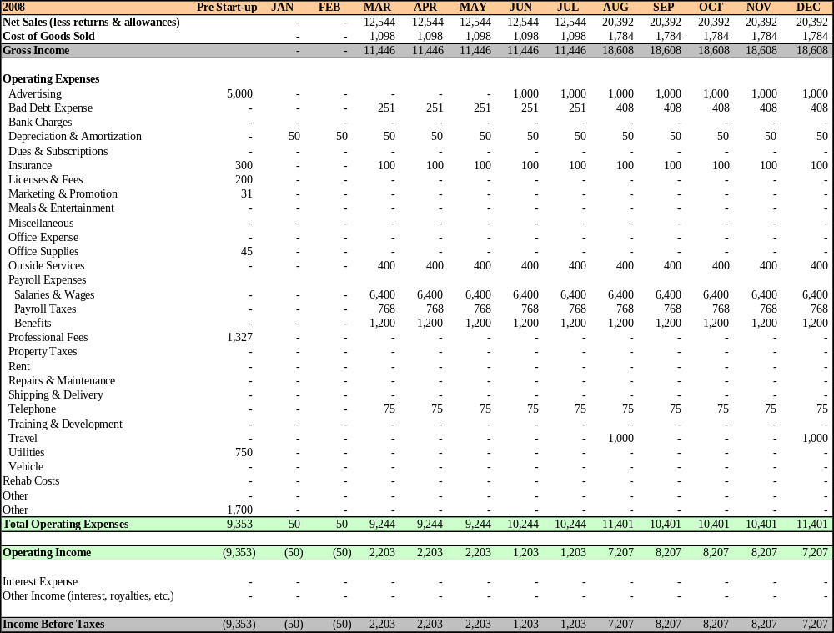
2009 Income Statement

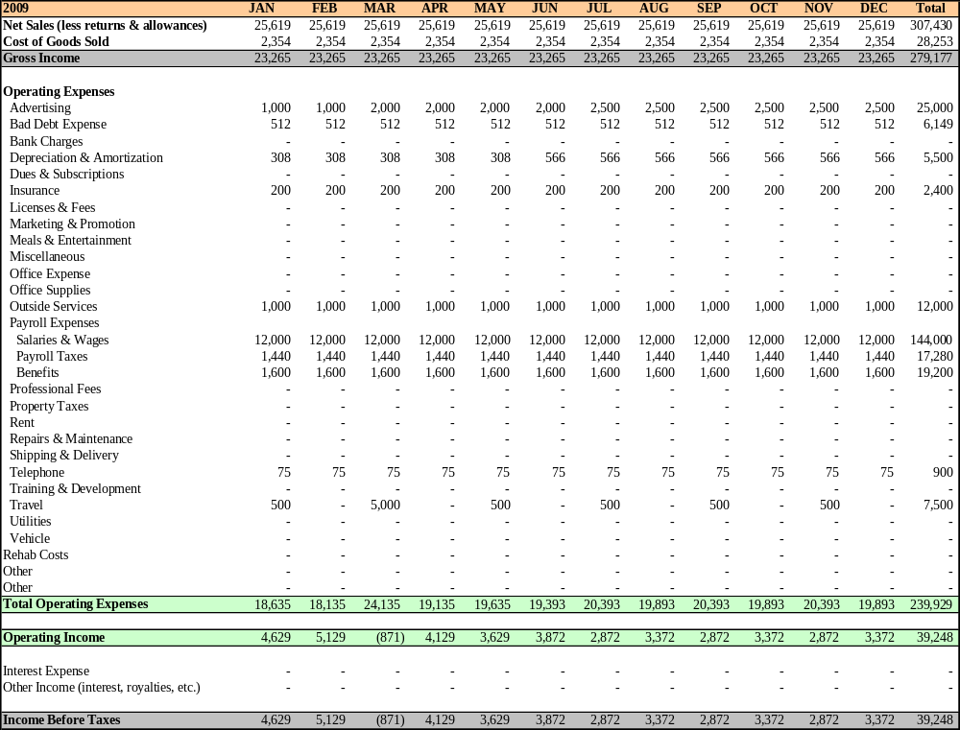

2010 Income Statement

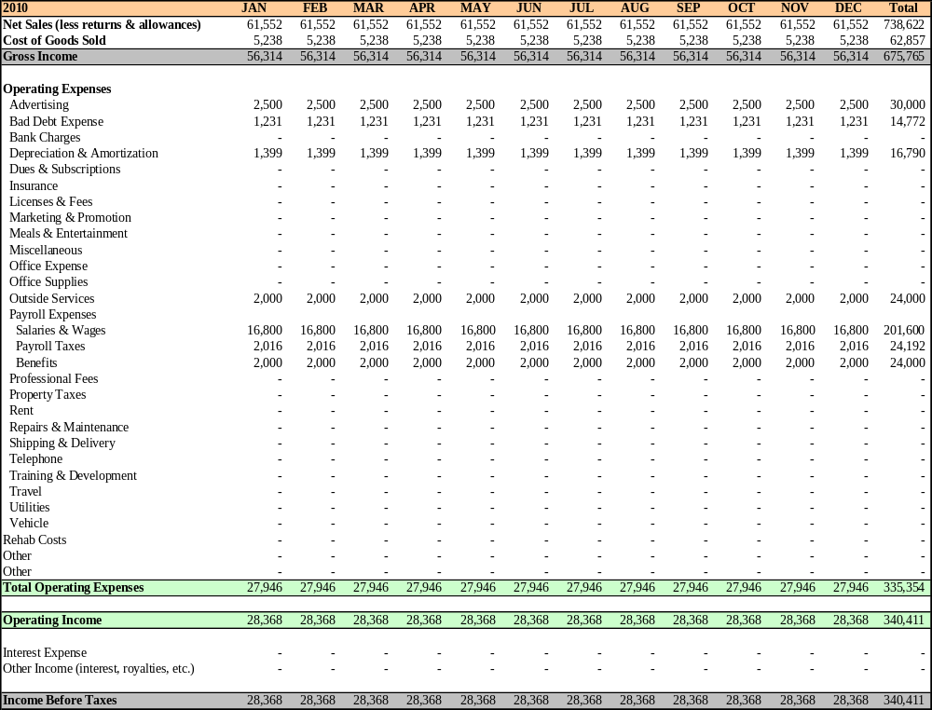

2008-2010 Annual Income Statements

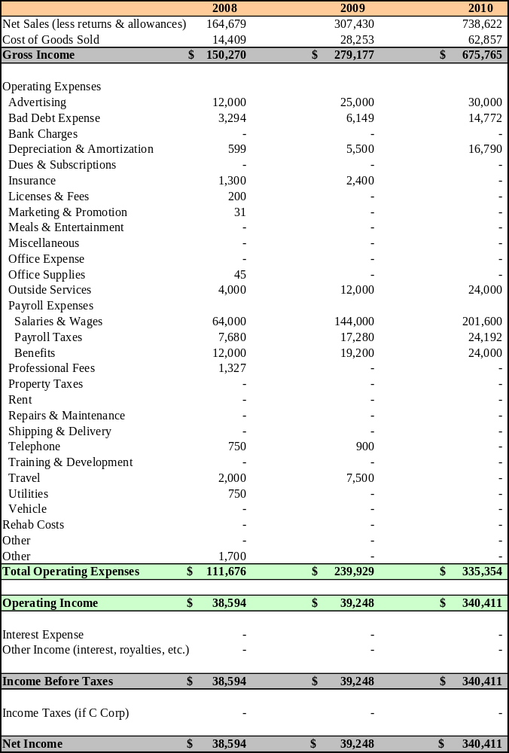
2008 Statement of Cash Flows

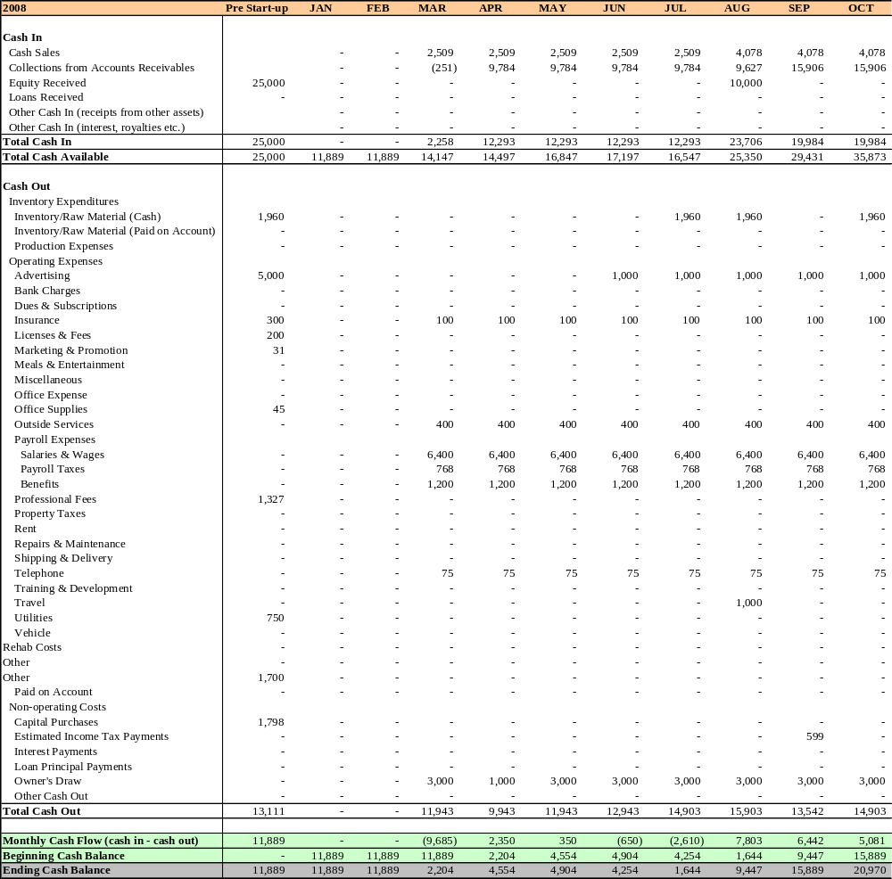
2009 Statement of Cash Flows

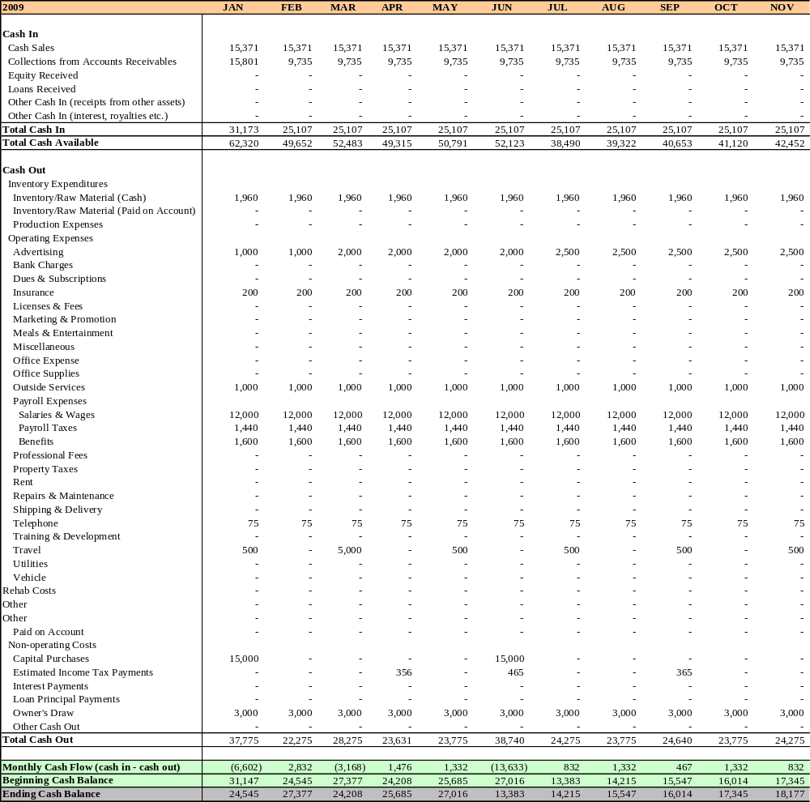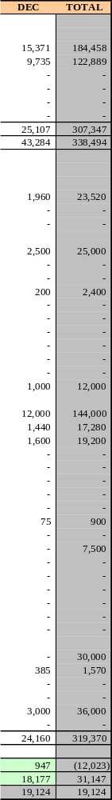
2010 Statement of Cash Flows

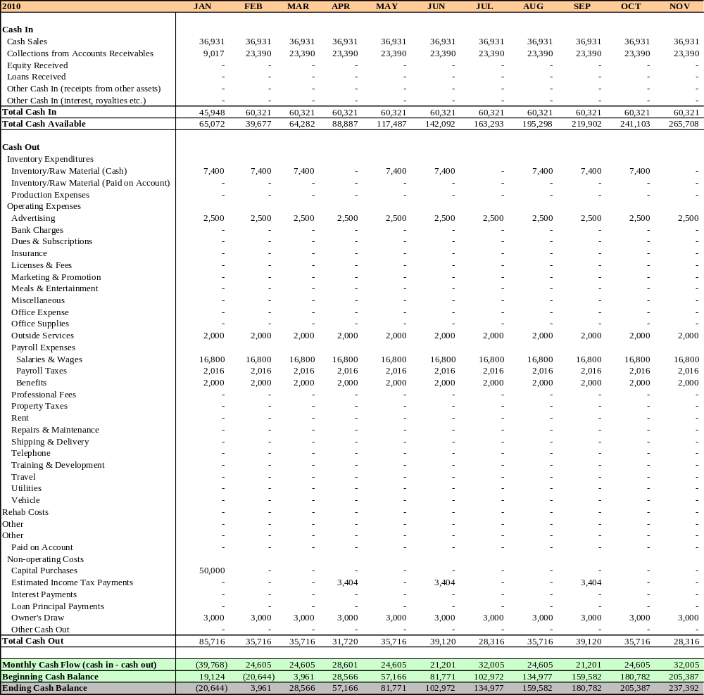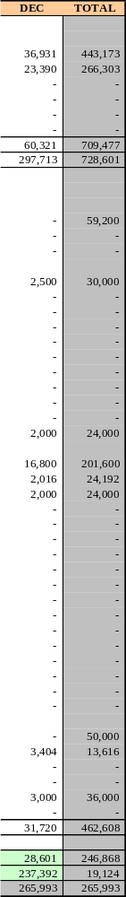
2008-2010 Annual Balance Sheets

